AAC Literacy PSU: comprehensive information and step-by-step guides about teaching formative literacy skills to people who use AAC (https://aacliteracy.psu.edu/)
Accessible Literacy Learning app (ALL)​: iPad app from Tobii Dynavox that targets those same formative literacy skills for people who use AAC.

Formative Literacy Skills
Sight word recognition
Recognizing a full written word on sight
Phoneme segmentation
Breaking down a spoken word into the composite sounds (e.g., hearing “cat” and knowing it is made up of the sounds /k/ /ae/ /t/)
Sound blending
Combining letter sounds into a single word (e.g., hearing the sounds /k/ /ae/ /t/ separately, and being able to blend them together to form “cat”)
Letter-sound correspondence
Matching a written letter to the sound it makes (e.g., seeing the written letter c and knowing that it makes the /k/ sound)
Decoding
Sounding out words by identifying their letter sounds, then blending those letter sounds together (e.g., reading the written word cat by knowing those letters make the sounds /k/ /ae/ /t/ and then blending them to form the word “cat”)

Apps with Transition to Literacy Feature
Integrates exposures to sight word recognition or decoding into the AAC system itself.
 | Go Visual  (Attainment Company) | Dedicated Devices  (Saltillo) | Snap Scene  (Tobii Dynavox) | Scene and Heard Pro (Therapy Box)
Single Word Recognition | Yes | Yes | Yes | Yes
Initial Phoneme Segmentation |  |  |  | Yes
CVC Word Decoding |  |  |  | Yes
Advanced Decoding |  |  |  | Yes

Example Activities with the T2L features embedded over telehealth (also applicable in person)
“I Spy” activities  (easy search and find, screen recording of app on next page with T2L feature) | 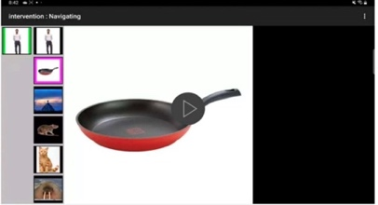  Page 1 Page 2 (screen recording of app)
Structured conversation  (preferred celebrities or characters – talking about what they see, screen recording of app on next page with T2L feature) | 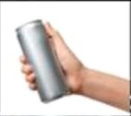  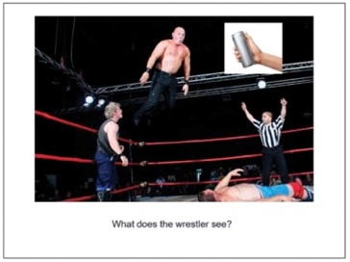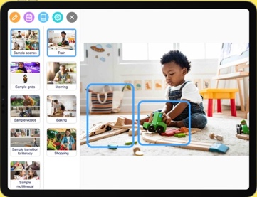  Page 1 Page 2 (screen recording of app)
Shared storybook reading  (program storybook in app, screen recordings with T2L feature for each/certain pages of the storybook) | 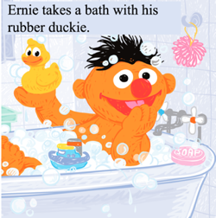  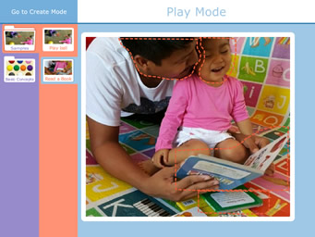
Shared video viewing with video VSDs  (program preferred videos – personal, from YouTube – in app, create still VSDs throughout vide, screen recordings with T2L feature) | 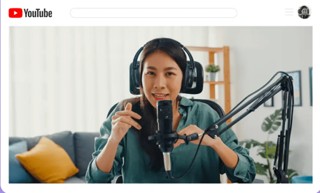  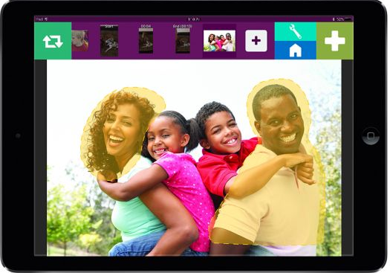

Alternative Access Options for Clients to Participate in Literacy Instruction and Assessment
- Sharing remote control over Zoom (mouse, touch screen)
- Eye gaze pointing
  - Looking at the quadrant of the screen – potentially smaller field size, spaced out to corners of the screen)
  - ETRAN board
- Selecting on personal AAC system (e.g., 1, 2, 3, 4 for the different response options)
- Partner assisted responding (communication partner relays response – be mindful of unintentional prompting)
Example Assessment of Literacy Learning for AAC Users
Decoding  (less challenging with one word and multiple picture response options – must know what the pictures represent) | 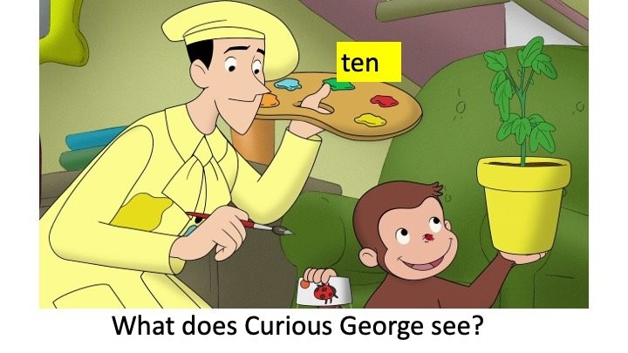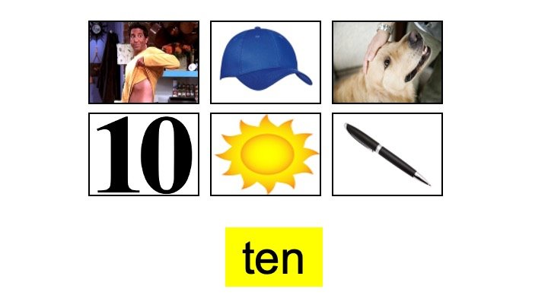  Slide 1 (establish target) Slide 2 (client matches picture to word)  Think strategically about foils (i.e., incorrect response options)  Minimal pairs, if possible!
Decoding  (more challenging with one picture and multiple text response options) | 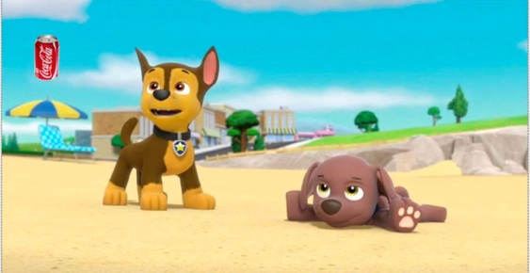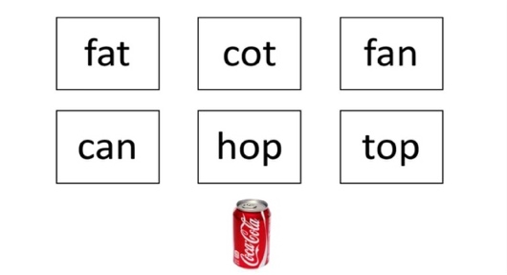  Slide 1 (establish target) Slide 2 (client matches word to picture)  Think strategically about foils (i.e., incorrect response options)  Minimal pairs, if possible!
Encoding  (for more advanced learners – could also respond by typing on the keyboard in the Notes section of the slide) | 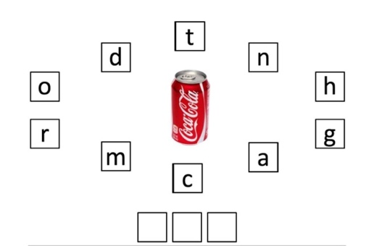  Slide 1 (establish target) Slide 2 (client spells word)
Sight Words | Materials would look similar to decoding, but words could be more varied (both target words and foils)

